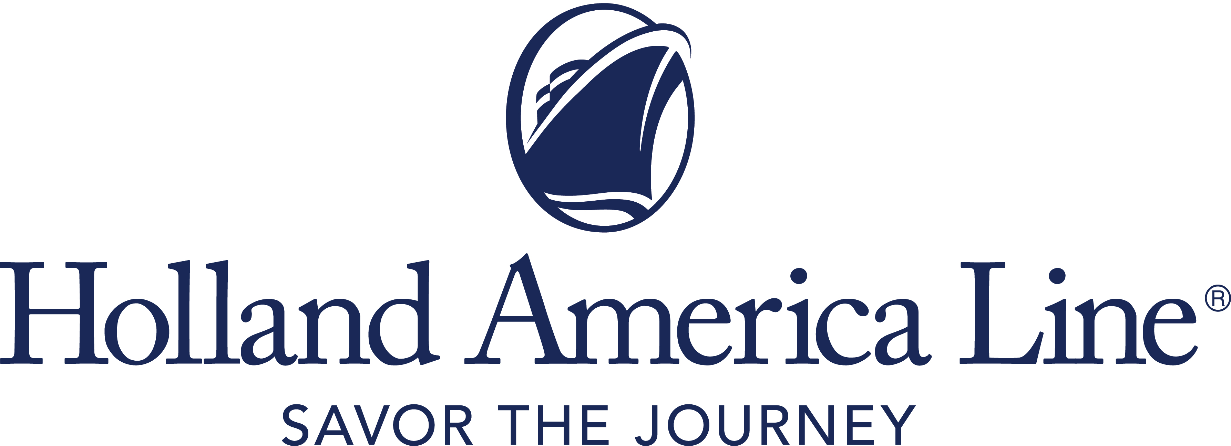
CONTACT: | Erik Elvejord
PHONE: | 800-637-5029, 206-626-9890
EMAIL: | pr@hollandamerica.com

Holland America Line Extends Pause in Cruise Operations

Pause to include April sailings, Alaska departures through mid-May, Mediterranean through early June and select Canada/New England

Seattle, Wash., Jan. 6, 2021 — As Holland America Line continues to prepare and develop its plans to meet the Framework for Conditional Sailing Order issued by the U.S. Centers for Disease Control and Prevention (CDC), the company is extending its pause of cruise operations for all departures through April 30, 2021. This includes Alaska, Mexican Riviera, Pacific Coast, Caribbean, Mediterranean and Canada/New England departures.

The line also will cancel all Alaska cruises through mid-May, Alaska departures on three ships through early June, any Land+Sea Journeys connected with canceled Alaska sailings, Mediterranean cruises through early June and Zaandam’s Canada/New England itineraries through August.

Cruises impacted by this pause in operation are:
- All cruise departures through April 30, 2021.
- Alaska: Eurodam and Oosterdam through the first week of June (roundtrip from Seattle); Koningsdam through mid-May (roundtrip from Vancouver, British Columbia, Canada); Nieuw Amsterdam and Noordam through mid-May (roundtrip Vancouver and between Vancouver and Whittier, Alaska); and Zuiderdam though early June (roundtrip from Vancouver).
- Mediterranean: Volendam cruises through early June (between Venice and Civitavecchia [Rome], Italy); Westerdam though early June (roundtrip from Venice or between Venice and Piraeus [Athens], Greece).
- Canada/New England: Zaandam cruises through August (between Boston, Massachusetts, and Montreal, Quebec, Canada).

Guests and their travel agents are being notified of the cancellations and options for Future Cruise Credits (FCC) and rebooking.

Holland America Line is closely following the protocol set forth by the CDC, and is preparing ships and implementing procedures to meet all requirements for approval to sail following the pause.

Guests Automatically Receive Bonus Future Cruise Credit
Cruises impacted automatically will be canceled, and no action is needed when opting for the Future Cruise Credit. All guests will receive an FCC per person as follows:

- Paid in Full: Those who have paid in full will receive 125% FCC of the base cruise fare paid to Holland America Line.
- Not Paid in Full: Those with bookings not paid in full will receive an FCC of double the amount of their deposit. The minimum FCC is $100 and the maximum will be an amount up to the base cruise fare paid.

The FCC is valid for 12 months from the date of issue and may be used to book sailings departing through Dec. 31, 2022. Noncruise fare purchases — such as shore excursions, gifts, dining and spa — will not be transferred to a new booking and will be refunded to the original form of payment. Other funds such as air fares paid to Holland America Line may be transferred to a new booking or will automatically be refunded via the method of payment used to purchase the services.

Full Refund Option Also Available
Guests who prefer a 100% refund of monies paid to Holland America Line can visit the Cancellation Preferences Form to indicate their preference no later than Feb. 15, 2021.

The above options are not applicable to guests booked on a charter sailing. Other booking and cancellation conditions and policies may apply if the cruise was not booked through Holland America Line. See the terms and conditions in the Cancellation Preferences Form for all details.

Holland America Line previously paused global cruise operations and canceled all departures on all ships through March 31, 2021.

For more information about Holland America Line, consult a travel advisor, call 1-877-SAIL HAL (877-724-5425) or visit hollandamerica.com.

— # # # —

Find Holland America Line on Twitter, Facebook and the Holland America Blog. Access all social media outlets via the home page at hollandamerica.com.

About Holland America Line [a division of Carnival Corporation and plc (NYSE: CCL and CUK)]
Holland America Line has been exploring the world since 1873 and was the first cruise line to offer adventures to Alaska and the Yukon more than 70 years ago. Its fleet of premium ships visits more than 470 ports in 98 countries around the world, offering an ideal mid-sized ship experience. A third Pinnacle-class ship, Rotterdam, is under construction and will join the fleet in July 2021.

The leader in premium cruising, Holland America Line’s ships feature innovative initiatives and a diverse range of enriching experiences focused on destination exploration and personalized travel. The best live music at sea fills each evening at Music Walk, and dining venues feature exclusive selections from Holland America Line's esteemed Culinary Council, comprising world-famous chefs.
In light of COVID-19, Holland America Line is currently enhancing health and safety protocols and how they may impact future cruises. Our actual offerings may vary from what is displayed or described in marketing materials. Review our current Cruise Updates, Health & Safety Protocols and CDC Travel Advisories.
FurtherPauseAprilSelect21

