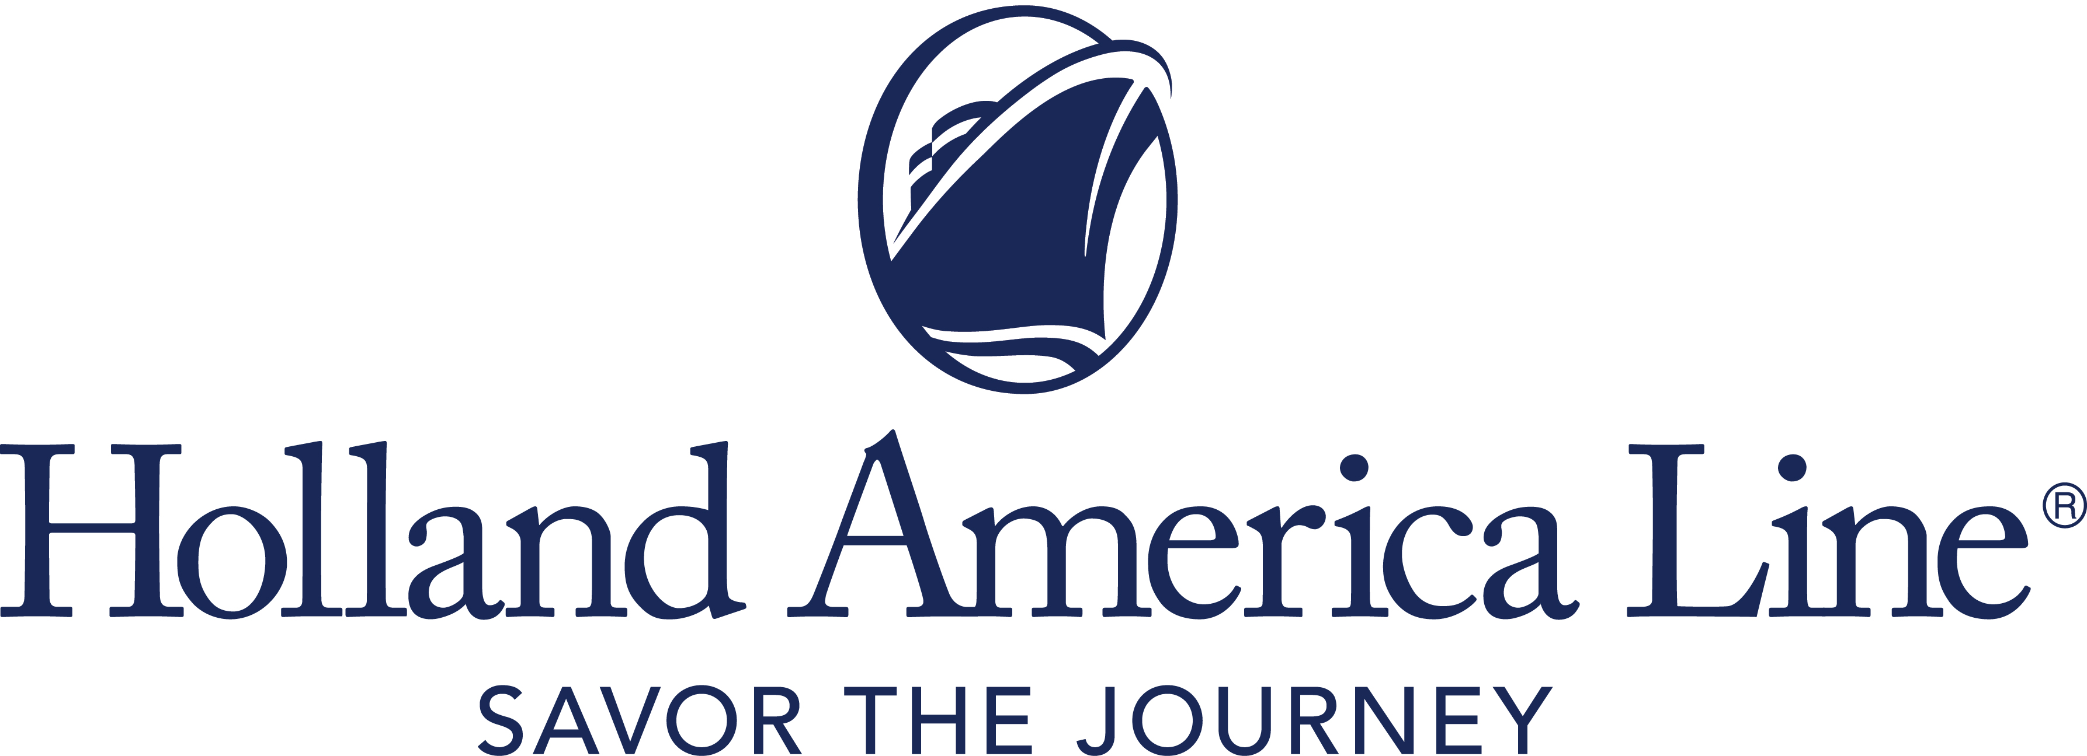
CONTACT: | Erik Elvejord
PHONE: | 800-637-5029, 206-626-9890
EMAIL: | pr@hollandamerica.com

Holland America Line Extends Cruise Pause to Include All Departures Sailing to or from a Canadian Port in 2021

Impacted voyages include Alaska, Canada/New England and Pacific Coastal sailings scheduled in 2021; similar cruises in 2022 not impacted

Seattle, Wash., Feb. 24, 2021 — As Holland America Line continues to review and assess its plans around the Canadian Transport Ministry’s Interim Order that closed Canadian ports and waters to passenger vessels, the company is extending its pause of cruise operations to now include all sailings that depart from or conclude in a Canadian port in 2021. This will include several Alaska, three Canada/New England and two Pacific Coastal cruises in summer and fall of this year. It also includes all Land+Sea Journeys.

At this time, Alaska cruises departing from mid-May and sailing roundtrip from Seattle, Washington, are not being canceled. Discussions are underway with Canadian and United States government authorities to try to find a path forward to preserve these sailings. As more information is known, an announcement will be made. Guests on impacted Alaska cruises and Land+Sea Journeys involving a Vancouver, British Columbia, Canada, gateway may not move to roundtrip Seattle cruises at this time, as these departures are not open for sale pending further announcements.

“Holland America Line, in alliance with our entire industry, is optimistic for the resumption of cruising around North America and worldwide,” said Gus Antorcha, president of Holland America Line. “However, we must be practical in our approach by acknowledging the limitations put in place by the current Canadian order that requires us to cancel select sailings. We thank our guests for their patience and understanding and know that they, like us, are eager to see cruising begin again soon.”

Cruises impacted by this pause in operation are:
- Alaska: Cruises through September 2021 to Alaska from all departure ports aboard Koningsdam, Nieuw Amsterdam, Noordam and Zuiderdam. This also includes any Land+Sea Journeys connected with canceled Alaska sailings.
- Pacific Coastal: Two sailings in early October aboard Koningsdam and Oosterdam.
- Canada/New England: Three cruises aboard Zaandam departing in September 2021.

All 2022 Alaska and Canada/New England cruises will operate as scheduled. The Canadian Interim Order expires Feb. 28, 2022.

Holland America Line is closely following the protocol set forth by the Centers for Disease Control and Prevention (CDC), and is preparing ships and implementing procedures to meet all requirements for approval to sail at the appropriate time.

Guests Automatically Rebooked in 2022 on Similar Cruise
Holland America Line is notifying guests and their travel advisors of their options. Guests on Alaska and Canada/New England canceled departures that are paid in full automatically will be rebooked on an equivalent cruise or Land+Sea Journey in 2022 at the fare paid for 2021 – with all cash and FCC funds moved to the new booking. No other action is needed when accepting the rebooked itinerary. Replacement 2022 booking confirmations will be automatically sent within 30 days of this announcement.

All guests receive the following options:

- Paid in Full: Those who have paid in full will be automatically rebooked to the same cruise or Land+Sea Journey in 2022 at the fare paid for 2021.
- Not Paid in Full: Those with bookings not paid in full may elect to be moved to the same cruise type or Land+Sea Journey in 2022 at the fare paid for 2021.

If guests decide not to accept a cruise booking in 2022 by March 31, 2021, they automatically default to receive an FCC of 110% of any cash paid on the booking. The minimum FCC is $25 and the maximum will be an amount up to the base cruise fare paid. Guests will retain any other FCC used for the canceled 2021 booking with all FCC amounts moved to their loyalty account for use on a future cruise booking. For all bookings in 2022, standard cancellation policies will apply.

Due to the fact that there are no equivalent cruises in 2022, Pacific Coastal cruise guests will receive the option for an FCC or full refund.

Full Refund Option Also Available
Guests who prefer a 100% refund of monies paid to Holland America Line can visit the Cancellation Preferences Form to indicate their preference no later than March 31, 2021.

The FCC is valid for sailings departing through Dec. 31, 2022. Noncruise fare purchases — such as shore excursions, air fares, gifts, dining and spa — will be transferred to a new booking or automatically refunded via the method of payment used to purchase the services to the original form of payment.

The above options are not applicable to guests booked on a charter sailing. Other booking and cancellation conditions and policies may apply if the cruise was not booked through Holland America Line. See the terms and conditions in the Cancellation Preferences Form for all details.

Holland America Line previously paused global cruise operations and canceled all departures on all ships through April 30, 2021, as well as Alaska cruises through mid-May or early June, Mediterranean cruises through early June and Canada/New England itineraries through August.

For more information about Holland America Line, consult a travel advisor, call 1-877-SAIL HAL (877-724-5425) or visit hollandamerica.com.

— # # # —

Find Holland America Line on Twitter, Facebook and the Holland America Blog. Access all social media outlets via the home page at hollandamerica.com.

About Holland America Line
Holland America Line has been exploring the world since 1873 and was the first cruise line to offer adventures to Alaska and the Yukon more than 70 years ago. Its fleet of premium ships visits more than 470 ports in 98 countries around the world, offering an ideal mid-sized ship experience. A third Pinnacle-class ship, Rotterdam, is under construction and will join the fleet in July 2021.

The leader in premium cruising, Holland America Line’s ships feature innovative initiatives and a diverse range of enriching experiences focused on destination exploration and personalized travel. The best live music at sea fills each evening at Music Walk, and dining venues feature exclusive selections from Holland America Line's esteemed Culinary Council, comprising world-famous chefs.
In light of COVID-19, Holland America Line is currently enhancing health and safety protocols and how they may impact future cruises. Our actual offerings may vary from what is displayed or described in marketing materials. Review our current Cruise Updates, Health & Safety Protocols and CDC Travel Advisories.
CanadaCruisesPause21

