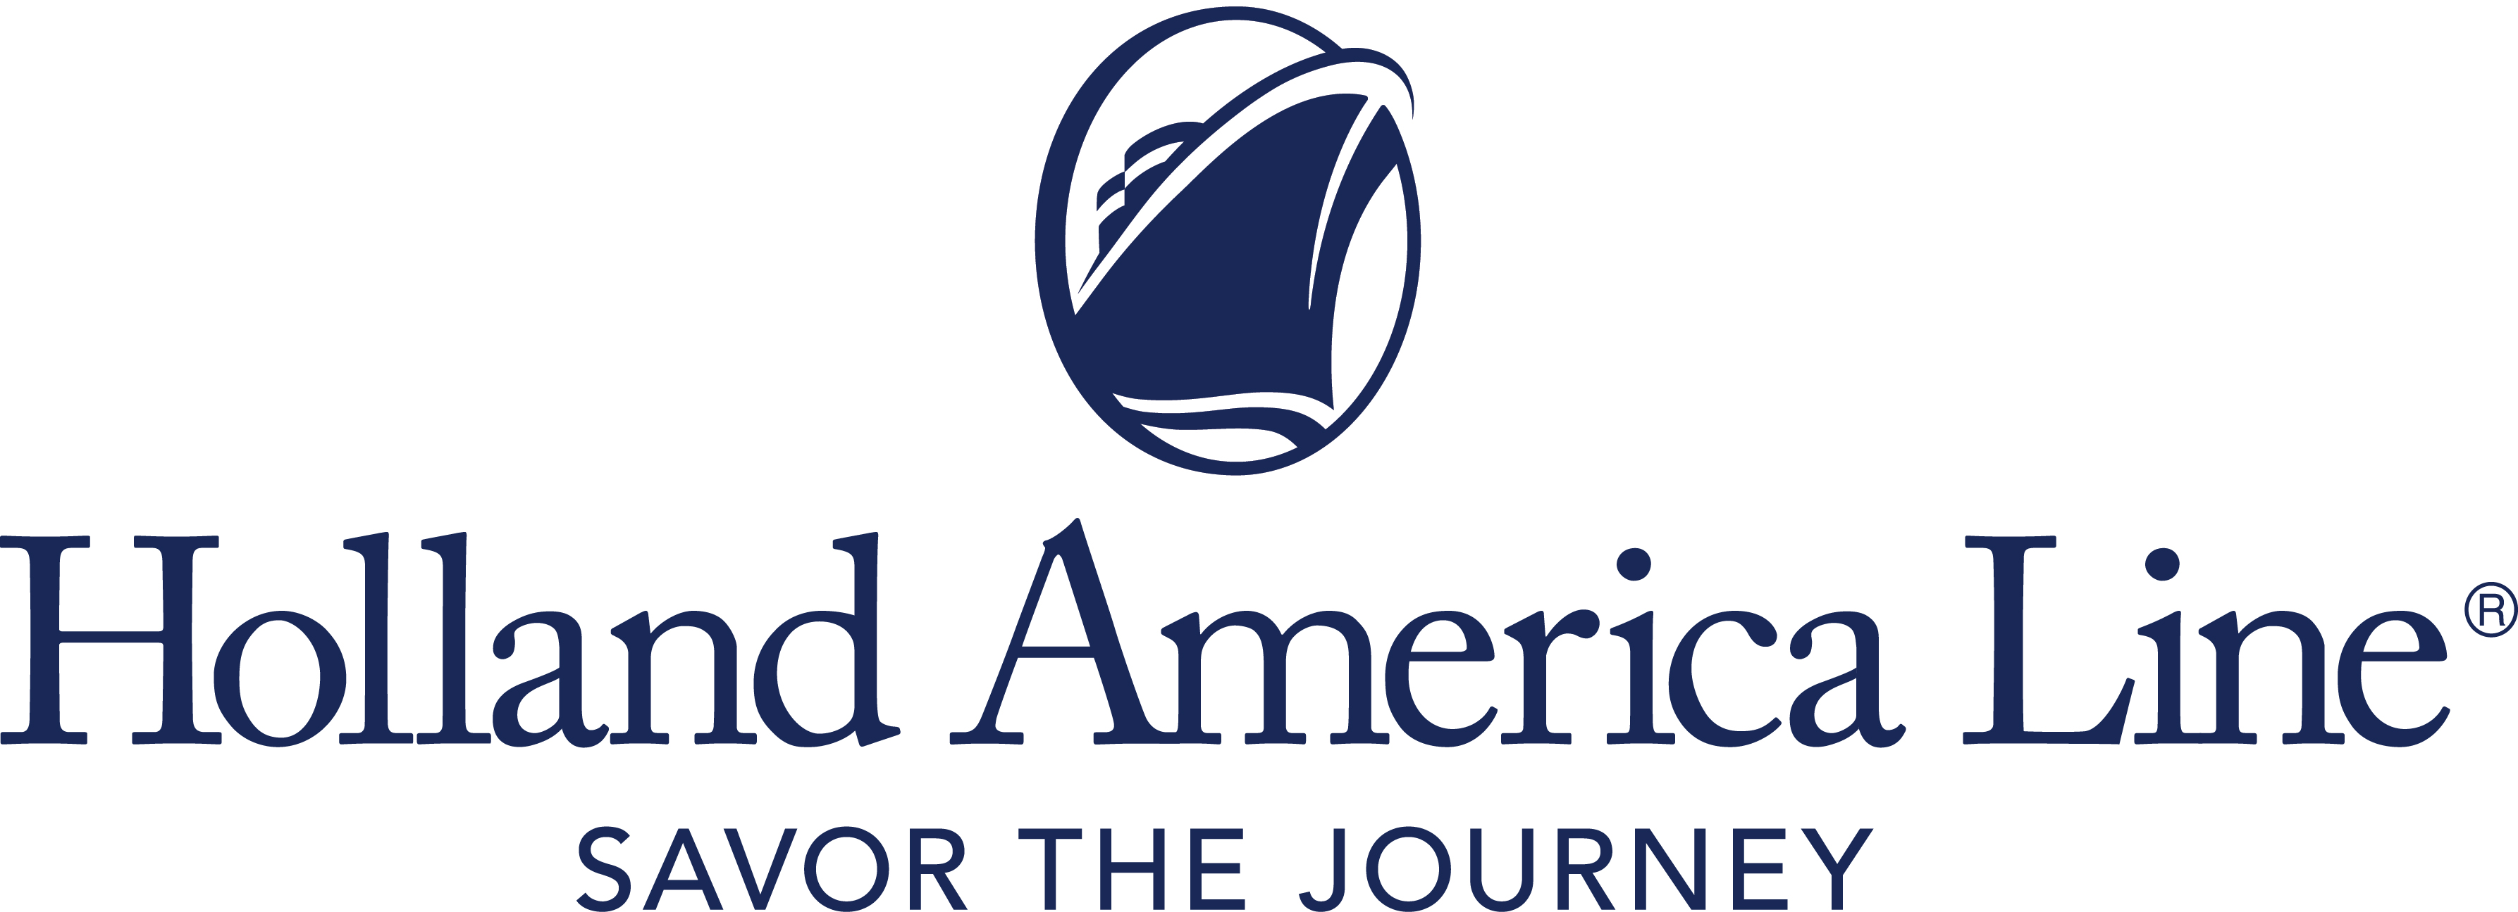
CONTACT: | Erik Elvejord
PHONE: | 800-637-5029, 206-626-9890
EMAIL: | pr@hollandamerica.com

Holland America Line Extends Cruise Pause to Include Europe Departures Through June 2021

Guests booked on the impacted voyages are able to select a comparable cruise in 2022 at the 2021 cruise fare

Seattle, Wash., March 9, 2021 — While Holland America Line continues to work with government and port authorities to develop its plans to return to cruising, the company is extending its pause of European cruise operations to include departures through June 30, 2021.

The pause will impact cruises departing in May and June on Nieuw Statendam, Volendam and Westerdam, along with the Collectors’ Voyages associated with those canceled cruises. Collectors’ Voyages combine nonrepeating itineraries for an extended, back-to-back cruise experience.

Cruises affected by this pause in operation are:
- Nieuw Statendam: Eight departures from May 2 through June 27, 2021, that include seven- and 14-day Norway and Baltic itineraries, as well as the 14- and 21-day Collectors’ Voyages of those cruises.
- Volendam: June 19, 2021, 14-day Adriatic Dream cruise and the 24-day Adriatic Dream and Greek Odyssey Collectors’ Voyage departing the same date.
- Westerdam: June 19, 2021, 12-day Greece and Adriatic Antiquities cruise and the 24-day Adriatic Antiquities and Mediterranean Romance Collectors’ Voyage departing the same date.

All Guests Able to Rebook in 2022 on a Comparable Cruise
Holland America Line is notifying all guests and their travel advisors of their options. Guests currently booked on the canceled Europe departures will be able to rebook on an equivalent cruise in 2022 at the 2021 fare – with all cash and Future Cruise Credit funds moved to the new booking. Guests will be offered a comparable cruise in 2022 to replace the canceled voyage and instructions on how to confirm this selection online.

If guests decide not to accept a cruise booking in 2022 by April 15, 2021, they automatically default to receive a Future Cruise Credit of 110% of any cash paid on the booking. The minimum FCC is $25 and the maximum will be an amount up to the base cruise fare paid. Guests will retain any other FCC used for the canceled 2021 booking with all FCC amounts moved to their loyalty account for use on a future cruise booking. For all bookings in 2022, standard cancellation policies apply.

Full Refund Option Also Available
Guests who prefer a 100% refund of monies paid to Holland America Line can visit the Cancellation Preferences Form to indicate their preference no later than April 15, 2021.

The FCC is valid for sailings departing through Dec. 31, 2022. Noncruise fare purchases — shore excursions, airfare, gifts, dining and spa — will be transferred to a new booking if possible or automatically refunded via the method of payment used to purchase the services.

The above options are not applicable to guests booked on a charter sailing. Other booking and cancellation conditions and policies may apply if the cruise was not booked through Holland America Line. See the terms and conditions in the Cancellation Preferences Form for all details.

Holland America Line previously paused global cruise operations and canceled all departures on all ships through April 30, 2021; Mediterranean cruises through early June; and all departures sailing to or from a Canadian port in 2021.

Holland America Line is closely following the protocols set forth by the Centers for Disease Control and Prevention and other authorities and is preparing ships and implementing procedures to meet all requirements for approval once a restart date is determined.

For more information about Holland America Line, consult a travel advisor, call 1-877-SAIL HAL (877-724-5425) or visit hollandamerica.com.

— # # # —

Find Holland America Line on Twitter, Facebook and the Holland America Blog. Access all social media outlets via the home page at hollandamerica.com.

About Holland America Line
Holland America Line has been exploring the world since 1873 and was the first cruise line to offer adventures to Alaska and the Yukon more than 70 years ago. Its fleet of premium ships visits more than 470 ports in 98 countries around the world, offering an ideal mid-sized ship experience. A third Pinnacle-class ship, Rotterdam, is under construction and will join the fleet in July 2021.

The leader in premium cruising, Holland America Line’s ships feature innovative initiatives and a diverse range of enriching experiences focused on destination exploration and personalized travel. The best live music at sea fills each evening at Music Walk, and dining venues feature exclusive selections from Holland America Line's esteemed Culinary Council, composed of world-famous chefs.
In light of the COVID-19 pandemic, Holland America Line is currently enhancing health and safety protocols, which may impact future cruises. Our actual offerings may vary from what is displayed or described in marketing materials. Review our current Cruise Updates, Health & Safety Protocols and CDC Travel Advisories.
EuropeJuneCruisePause21

