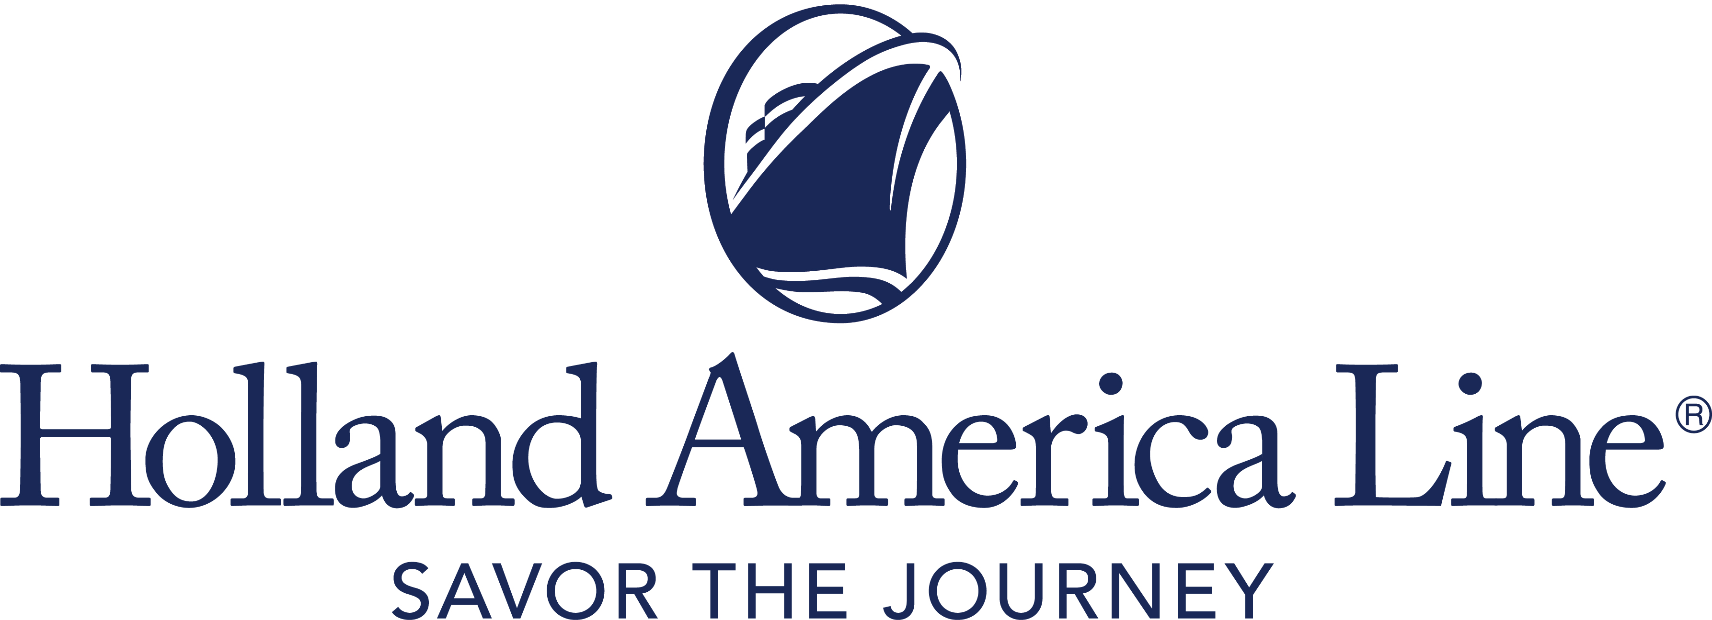
CONTACT: | Erik Elvejord
PHONE: | 800-637-5029, 206-626-9890
EMAIL: | pr@hollandamerica.com

Holland America Line Pauses All Alaska Cruises Sailing Roundtrip from Seattle Scheduled to Depart in June 2021

Six total voyages on Eurodam and Oosterdam are impacted; guests can rebook a comparable voyage in 2022

Seattle, Wash., March 16, 2021 — Holland America Line has announced it is extending its pause of cruise operations to now include all June 2021 roundtrip sailings to Alaska from Seattle, Washington. This includes six cruises on Eurodam and Oosterdam with a call at Victoria, British Columbia, Canada.

At this time, Alaska cruises sailing roundtrip from Seattle departing in July and onward have not been canceled. Following the earlier Canadian Transport Ministry Interim Order that closed Canadian ports to passenger vessels, discussions continue with Canadian and United States government authorities to try to preserve remaining Seattle Alaska sailings. Holland America Line previously announced the cancellation of all 2021 Alaska cruises to or from Vancouver, British Columbia, Canada.

“We continue to stay actively engaged in dialogue with authorities in Canada and the United States to understand what cruise opportunities may still exist in Alaska, knowing how important this market is not only to our brand, but to the communities and individuals who depend on our business,” said Gus Antorcha, president of Holland America Line. “We share with our guests the disappointment of canceling these voyages, and we remain hopeful that we can operate some of the Alaska cruise season.”

All Guests Will be Moved to a Comparable Alaska Cruise in 2022
Guests currently booked on the canceled roundtrip Seattle-Alaska June departures will automatically be moved to an equivalent cruise in 2022 at the 2021 fare – with all cash and Future Cruise Credit funds moved to the new booking.

Once a new booking confirmation is received, if guests decide not to accept the 2022 cruise booking, they will have the option to decline the booking and receive an FCC of 110% of any cash paid. Guests will also be able to request a full refund of all monies paid to Holland America Line.

The minimum FCC is $25 and will be valid for sailings departing through Dec. 31, 2022, and will be moved to the guest loyalty account. Non–cruise fare purchases (shore excursions, airfare, gifts, dining and spa) will be transferred to a new booking or automatically refunded via the method of payment used to purchase the goods or services.

Other booking and cancellation conditions and policies may apply if the cruise was not booked through Holland America Line.

For more information about Holland America Line, consult a travel advisor, call 1-877-SAIL-HAL (877-724-5425) or visit hollandamerica.com.

— # # # —

Find Holland America Line on Twitter, Facebook and the Holland America Blog. Access all social media outlets via the home page at hollandamerica.com.

About Holland America Line
Holland America Line has been exploring the world since 1873 and was the first cruise line to offer adventures to Alaska and the Yukon more than 70 years ago. Its fleet of premium ships visits more than 470 ports in 98 countries around the world, offering an ideal mid-sized ship experience. A third Pinnacle-class ship, Rotterdam, is under construction and will join the fleet in July 2021.

The leader in premium cruising, Holland America Line’s ships feature innovative initiatives and a diverse range of enriching experiences focused on destination exploration and personalized travel. The best live music at sea fills each evening at Music Walk, and dining venues feature exclusive selections from Holland America Line's esteemed Culinary Council, comprising world-famous chefs.
In light of COVID-19, Holland America Line is currently enhancing health and safety protocols and how they may impact future cruises. Our actual offerings may vary from what is displayed or described in marketing materials. Review our current Cruise Updates, Health & Safety Protocols and CDC Travel Advisories.

SeattleJunePause21

