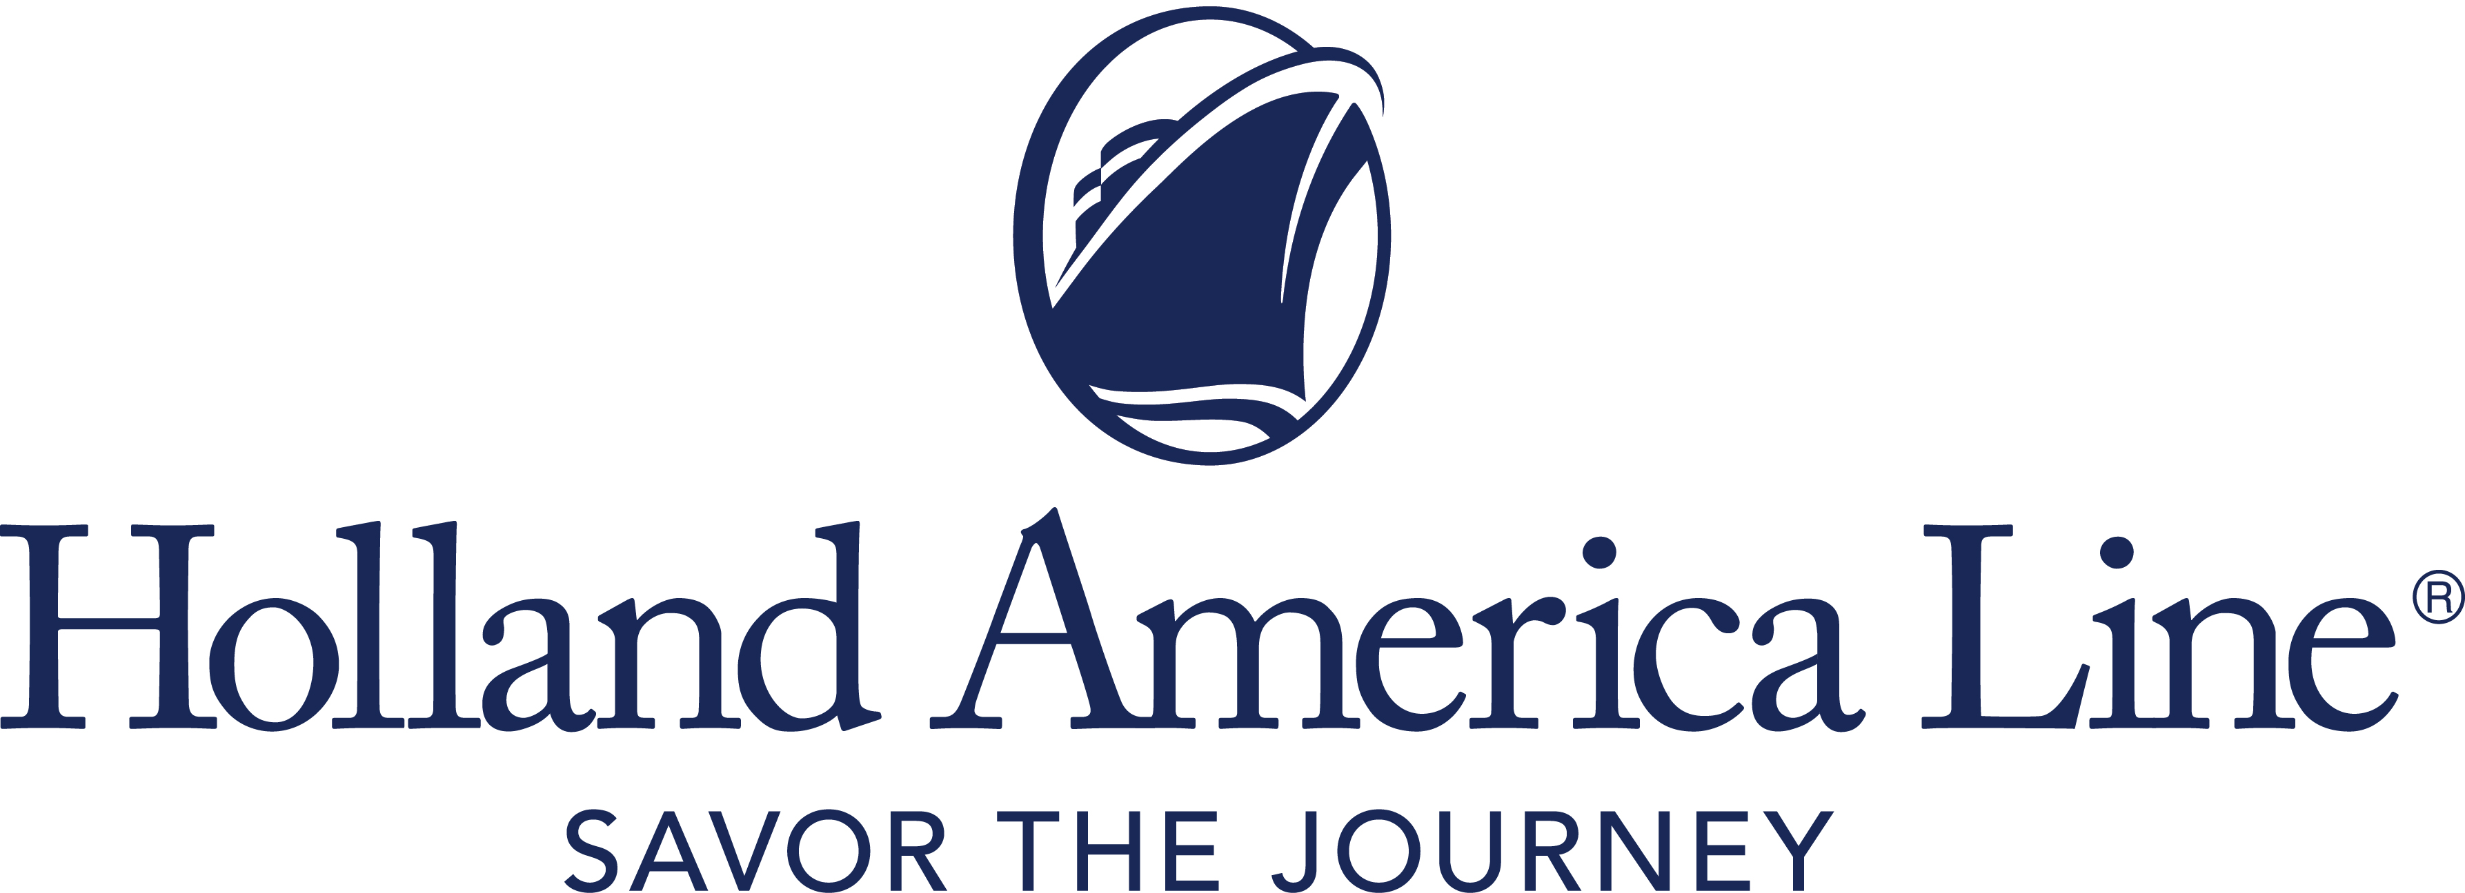
CONTACT: | Erik Elvejord
PHONE: | 800-637-5029, 206-626-9890
EMAIL: | pr@hollandamerica.com

Holland America Line Announces Plans to Restart Cruising to Alaska from Seattle in July 2021
Click to tweet: .@HALcruises announces plans to restart cruising to #Alaska this summer roundtrip from Seattle. Seven-day itineraries aboard Nieuw Amsterdam will call at Juneau, Icy Strait Point, Sitka and Ketchikan. First #cruise would depart July 24.

Seattle, Wash., May 20, 2021 — Following passage of the Alaska Tourism Restoration Act, work with Alaska government officials, and recent guidance from the U.S. Centers for Disease Control and Prevention (CDC), Holland America Line is announcing plans to restart cruising to Alaska in July roundtrip from Seattle, Washington, aboard Nieuw Amsterdam.

Bookings are open for the ten Saturday departures that will operate from July 24 through Oct. 2. The seven-day “Alaskan Explorer” itinerary calls at Juneau, Icy Strait Point, Sitka and Ketchikan. Scenic cruising in Alaska’s iconic locales includes Glacier Bay and Stephens Passage.

Plans for these cruises to fulfill Holland America Line’s obligations under the Passenger Vessel Services Act (PVSA) are expected to be approved, as are final instructions from CDC, and the company is beginning the return-to-cruising preparation process effective immediately.

“Holland America Line has been cruising to Alaska for nearly 75 years, and we feel deeply committed to trying to help our friends in ‘The Great Land’ get back on their feet in any way we can this summer,” said Gus Antorcha, president of Holland America Line. “Given the recent positive collaboration from the CDC, as well as optimism about a resolution with the PVSA, we feel like it’s now or never to give ourselves a chance to bring cruising back to Alaska this year.

“We would like to offer our sincerest appreciation to Senators Lisa Murkowski and Dan Sullivan, Congressman Don Young and Governor Mike Dunleavy for their tireless efforts on behalf of the many small businesses that are the backbone of Alaska tourism.”

“The Last Frontier is eager to welcome the return of the cruise industry this summer to restart our economy,” said Alaska Governor Mike Dunleavy. “Cruising has a tremendous impact on the people of our state and our communities, especially in the southeast, and we’re thrilled to finally see a light with the impending return of the cruise ships.”

On board, Holland America Line will continue to offer the amenities that are a hallmark of the brand. Dining will be available in all restaurants and specialty venues, as well as room service. Entertainment will be in full swing in the main show lounge, and live music will be featured in Lincoln Center Stage, B.B. King’s Blues Club and Billboard Onboard. Port-to-Table culinary demonstrations and other enrichment programming will bring Alaska and its culture on board through engaging activities. To accommodate physical distancing, additional performances may be added.

Alaska cruises also feature expanded onboard programming. Guests can engage with an Alaska naturalist, while EXC Talks and special presentations explore local topics such as Alaska’s bush pilots and famous Iditarod race. In Glacier Bay, the ship takes on a National Park Ranger and Huna native speaker.

Voted Best in Alaska
Holland America Line was named the top pick for Alaska cruises in the 2020 AFAR Travelers’ Awards, 2020 Porthole Cruise Magazine Editor-in-Chief Awards, 2019 Cruise Critic Cruisers’ Choice Destination Awards and 2019 TravelAge West Wave Awards Editor’s Pick, confirming its position as the best cruise line in Alaska by some of the world’s most experienced travelers and cruise experts.

Cruise and Stay Healthy
These Holland America Line cruises in 2021 to Alaska are available for guests who have received their final dose of an approved COVID-19 vaccine at least 14 days prior to the beginning of the cruise and have proof of vaccination. Shipboard crew vaccinations will also be in accordance with CDC guidelines.

Holland America Line guests will be required to comply with all health and safety protocols in place at the time of departure for travel to and from the ship, as well as all onboard protocols and procedures for visiting ports.

As of now and subject to change as CDC, public health and medical guidance evolves, Holland America Line’s onboard program provides steps to enhance public health. Travelers are encouraged to regularly check hollandamerica.com since updates will be posted as new procedures are finalized and existing protocols may evolve.

Full details, including information on shore excursions, are being finalized and will be shared in the coming weeks at hollandamerica.com. Attractive airfares will be available through Holland America Line’s FlightEase program. Flexible cancellation terms, including our COVID-19 Protections, are offered through “Book with Confidence” when booked by June 30, 2021, for sailings through Dec. 31, 2021. The cruise line’s Cancellation Protection Plan also allows cancellation up to 24 hours in advance.

Fares for Nieuw Amsterdam's seven-day Alaska cruises begin at a “Have It All” premium package rate of $1,079 per person that includes four high-value amenities: one shore excursion, a Signature Beverage Package, specialty dining in the Pinnacle Grill or Tamarind, and a Wi-Fi Surf Package to stay connected throughout the cruise. Cruise-only fares start at $799 per person, double occupancy. Taxes, fees and port expenses are additional.

Guests who were scheduled to sail on Oosterdam’s roundtrip Seattle cruises with a Sunday departure will be moved to similar accommodations on sister-ship Nieuw Amsterdam, departing on Saturdays. Eurodam guests who were affected by that ship’s move to Greece also will be moved to similar accommodations on Nieuw Amsterdam.

For more information about Holland America Line, consult a travel advisor, call 1-877-SAIL HAL (877-724-5425) or visit hollandamerica.com.

Editor’s note: Photos are available at https://www.cruiseimagelibrary.com/c/qjfnnmwm.

— # # # —

Find Holland America Line on Twitter, Facebook and the Holland America Blog. Access all social media outlets via the home page at hollandamerica.com.

About Holland America Line [a division of Carnival Corporation and plc (NYSE: CCL and CUK)]
Holland America Line has been exploring the world since 1873 and was the first cruise line to offer adventures to Alaska and the Yukon more than 70 years ago. Its fleet of premium ships visits nearly 400 ports in 114 countries around the world, offering an ideal mid-sized ship experience. A third Pinnacle-class ship, Rotterdam, is under construction and will join the fleet in July 2021.

The leader in premium cruising, Holland America Line’s ships feature innovative initiatives and a diverse range of enriching experiences focused on destination exploration and personalized travel. The best live music at sea fills each evening at Music Walk, and dining venues feature exclusive selections from Holland America Line's esteemed Culinary Council of world-famous chefs.

In light of COVID-19, Holland America Line is currently enhancing health and safety protocols and how they may impact future cruises. Our actual offerings may vary from what is displayed or described in marketing materials. Review our current Cruise Updates, Health & Safety Protocols and CDC Travel Advisories.

RTSAlaska21

