Holland America Line
Frequently Asked Questions
Online Check-In Flow Changes

Q. What is changing?
A. Beginning June 14, 2021 - The location where guests accept the cruise contract is moving and guests will be required to accept a Risk Acceptance form or confirm receipt of a Risk Notification form depending on their residency. Additionally, there will not be separate cruise contract version based on country of residency. The high level contract versions will be North America, European Union, United Kingdom, and Australia. Residents in countries not under those umbrellas will get the North America cruise contract.
Q. Who will receive a Risk Acceptance and who will receive a Risk Notification?
A. Residents of the United States and Canada will be required to accept the Risk Acceptance. Guests who are residents of any other country will need to confirm receipt of the Risk Notification.
Q. How does OLCI know which Risk form to provide guests?
A. The residency information will be retrieved from POLAR. If the guests does not have a residency on file the OLCI system will take them to a page that asked the user to select their country of residency. Note: Residency may be different from passport/nationality. We serve up the notice based on their current residency.
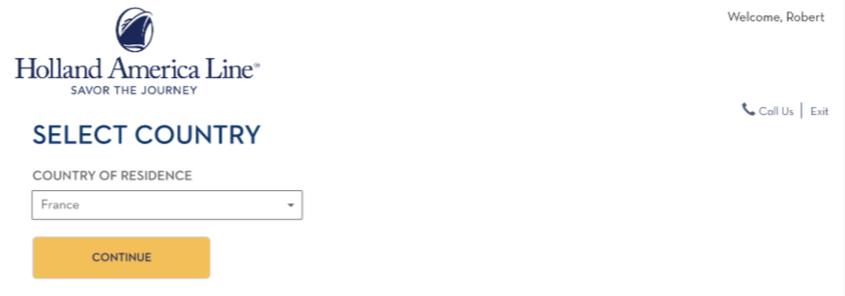
Q. Where will the Cruise Contract and Risk form be located in the new flow?
A. Once guests have entered the applicable criteria on the OLCI login page they will be taken to the landing page the same and will select the guest on the booking they will be entering OLCI data for the same way as they have in the past. Once they have selected the guest a new page between the landing page and the task flow will present the applicable Risk form and Cruise Contracts. Once they have reviewed and accepted the applicable Risk form they will be taken to a screen with the applicable cruise contract. After the Risk form and contract have been accepted the check in task flow will be presented. The rest of the OLCI flow will be similar to what guests have experienced in the past.

Q. Can a Contact Center Agent, Personal Cruise Consultant, or Travel Advisor accept this on behalf of the guest?
A. No. The cruise contract and the applicable Risk form need to be accepted by the guest, or by a guardian if accepting for a minor. If there is a minor on the booking the Risk form and Cruise Contract pages will note the minor by name and provide a section for the individual accepting on behalf of the minor to select their name from a drop down list of parties on the booking and they will need to click the option that states they are accepting on behalf of the minor.
Risk Acceptance Page
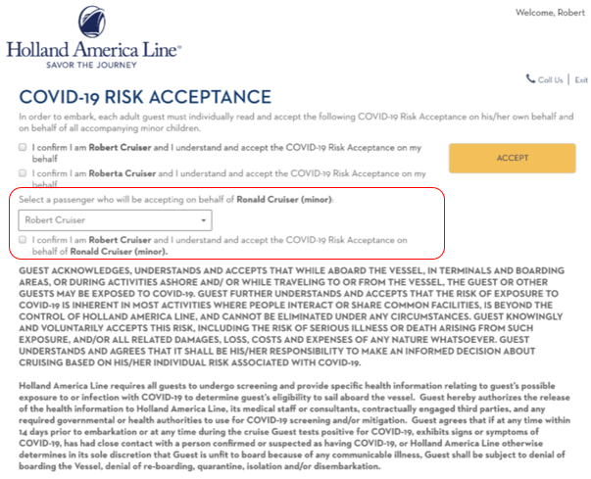

Cruise Contract Page
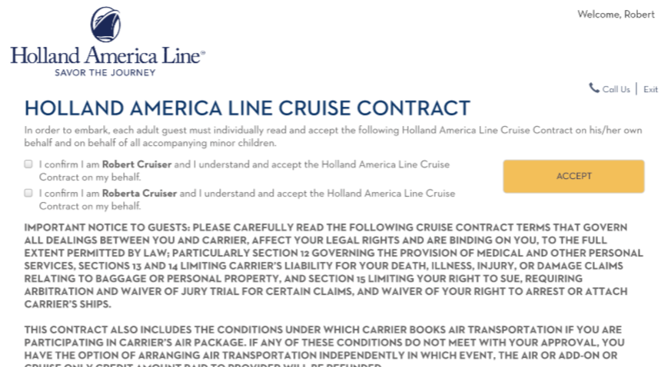

Q. Will there still be a Contract tab in OLCI?
A. Yes. Instead of the guest accepting the contract on this page it will now show who accepted the contract and the applicable Risk form for each party. Guests will be able to click on links on this page to view the documents they have accepted if they wish to refer back to them after accepting.
