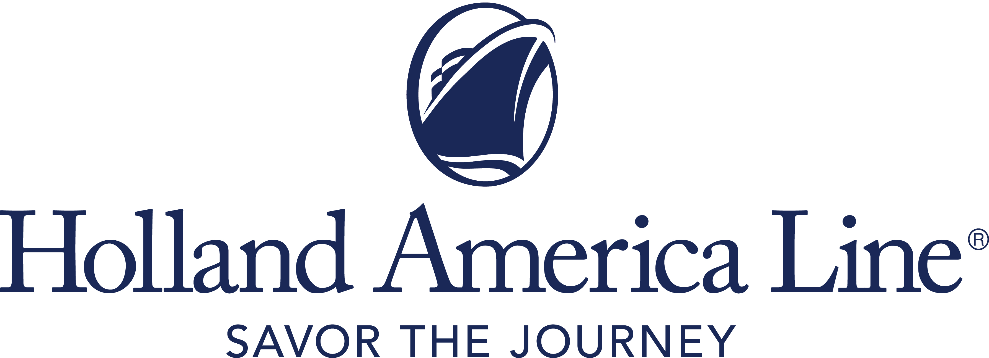
CONTACT: | Erik Elvejord
PHONE: | 800-637-5029, 206-626-9890
EMAIL: | pr@hollandamerica.com

Holland America Line’s Eurodam Extends 2021 Mediterranean Cruise Season and Assumes Previously Scheduled Westerdam Itineraries

Ship to sail five 12-day itineraries from Italy, Greece or Spain

Seattle, Wash., May 25, 2021 — Following a series of four cruises to Greece in summer 2021, Holland America Line’s Eurodam will assume the previously scheduled cruises of Westerdam that span the Mediterranean. From Sept. 12 through its Oct. 30 transatlantic departure, Eurodam will offer five 12-day itineraries roundtrip from Venice, Italy; between Venice and Piraeus (Athens), Greece; Venice and Barcelona, Spain; or from Barcelona to Fort Lauderdale, Florida. Bookings open Thursday, May 27, for these cruises.

Guests who were booked on Westerdam cruises automatically will be rebooked on the same departure date aboard Eurodam in a comparable stateroom. As a Signature Class vessel, Eurodam has a slightly larger capacity and will be able to accommodate all Westerdam guests (Eurodam 2,104; Westerdam 1,964).

Holland America Line previously announced Eurodam would restart cruising in the Mediterranean Aug. 15, 2021, and offer three seven-day departures roundtrip from Piraeus and one seven-day cruise from Piraeus to Venice.

Mediterranean Cruise Itineraries (all cruises are 12 days):
- Sept. 12: Venice; Zadar and Hvar, Croatia; Kotor, Montenegro; Argostólion, Crete, Rhodes (overnight), Marmaris, Mykonos and Piraeus (overnight), Greece.
- Sept. 24: Piraeus; Istanbul (overnight) and Kusadasi (Ephesus), Turkey; Sarandë, Albania; Dubrovnik, Korcula and Rijeka, Croatia; Koper, Slovenia; Venice (overnight).
- Oct. 6: Venice; Katakolon (Olympia), Piraeus, Rhodes (overnight), Santorini and Crete, Greece; Kotor; Korcula; Venice (overnight).
- Oct. 18: Venice (overnight); Dubrovnik; Kotor; Corfu and Katakolon, Greece; Naples, Civitavecchia (Rome), and Livorno (Pisa/Florence), Italy; Cannes and Marseille (Provence), France; Barcelona.
- Oct. 30: Barcelona, Cartagena, Malaga (Granada) and Cadiz (Seville), Spain; Lisbon, Portugal; Funchal and Ponta Delgada, Madeira; Fort Lauderdale.

The 12-day cruises can be combined to form an epic 24-day Collectors’ Voyage that offers an in-depth exploration of the region. The Mediterranean itineraries were designed to offer nonrepeating ports on back-to-back itineraries to enable guests to visit more ports and more countries on one extended voyage. Booking a Collectors’ Voyage represents a significant savings off booking the two itineraries separately.

Immediately following the transatlantic crossing, Eurodam is expected to begin its scheduled Caribbean season of cruises roundtrip from Fort Lauderdale. From November 2021 through March 2022, guests can embark on seven-, 10- and 11-day itineraries that explore the eastern, southern and tropical Caribbean, as well as partial Panama Canal cruises that spend a day on Gatun Lake.

Cruise and Stay Healthy
These Holland America Line cruises in 2021 to the Mediterranean are available for guests who have received their final dose of an approved COVID-19 vaccine at least 14 days prior to the beginning of the cruise and have proof of vaccination.

Holland America Line guests will be required to comply with all health and safety protocols in place at the time of departure for travel to and from the ship, as well as all onboard protocols and procedures for visiting ports. Travelers are encouraged to regularly check hollandamerica.com since updates will be posted as new procedures are finalized and existing protocols evolve.

Full details, including information on shore excursions, are being finalized and will be shared in the coming weeks at hollandamerica.com. Attractive airfares will be available through Holland America Line’s FlightEase program. Flexible cancellation terms, including COVID-19 Protections, are offered through “Book with Confidence” when booked by June 30, 2021, for sailings through Dec. 31, 2021. The cruise line’s Cancellation Protection Plan allows cancellation up to 24 hours in advance of departure.

Fares for Eurodam’s 12-day Mediterranean cruises begin at a “Have It All” premium package rate of $2,299 per person that includes four high-value amenities: two shore excursions, a Signature Beverage Package, one night specialty dining in both Pinnacle Grill and Tamarind, and a Wi-Fi Surf Package to stay connected throughout the cruise. Cruise-only fares start at $1,699 per person, double occupancy. Taxes, fees and port expenses are additional.

Holland America Line previously canceled eight Europe cruises in July and August aboard Nieuw Statendam and Volendam, as well as two Caribbean cruises in October and November on Eurodam. The Caribbean cancellations were made to accommodate the Mediterranean cruises Eurodam will now operate.

For more information about Holland America Line, consult a travel advisor, call 1-877-SAIL HAL (877-724-5425) or visit hollandamerica.com.

— # # # —

Find Holland America Line on Twitter, Facebook and the Holland America Blog. Access all social media outlets via the home page at hollandamerica.com.

About Holland America Line
Holland America Line has been exploring the world since 1873 and was the first cruise line to offer adventures to Alaska and the Yukon more than 70 years ago. Its fleet of premium ships visits nearly 400 ports in 114 countries around the world, offering an ideal mid-sized ship experience. A third Pinnacle-class ship, Rotterdam, is under construction and will join the fleet in July 2021.
The leader in premium cruising, Holland America Line’s ships feature innovative initiatives and a diverse range of enriching experiences focused on destination exploration and personalized travel. The best live music at sea fills each evening at Music Walk, and dining venues feature exclusive selections from Holland America Line's esteemed Culinary Council of world-famous chefs.
In light of COVID-19, Holland America Line is currently enhancing health and safety protocols and how they may impact future cruises. Our actual offerings may vary from what is displayed or described in marketing materials. Review our current Cruise Updates, Health & Safety Protocols and CDC Travel Advisories.
EUDMFallMed21

