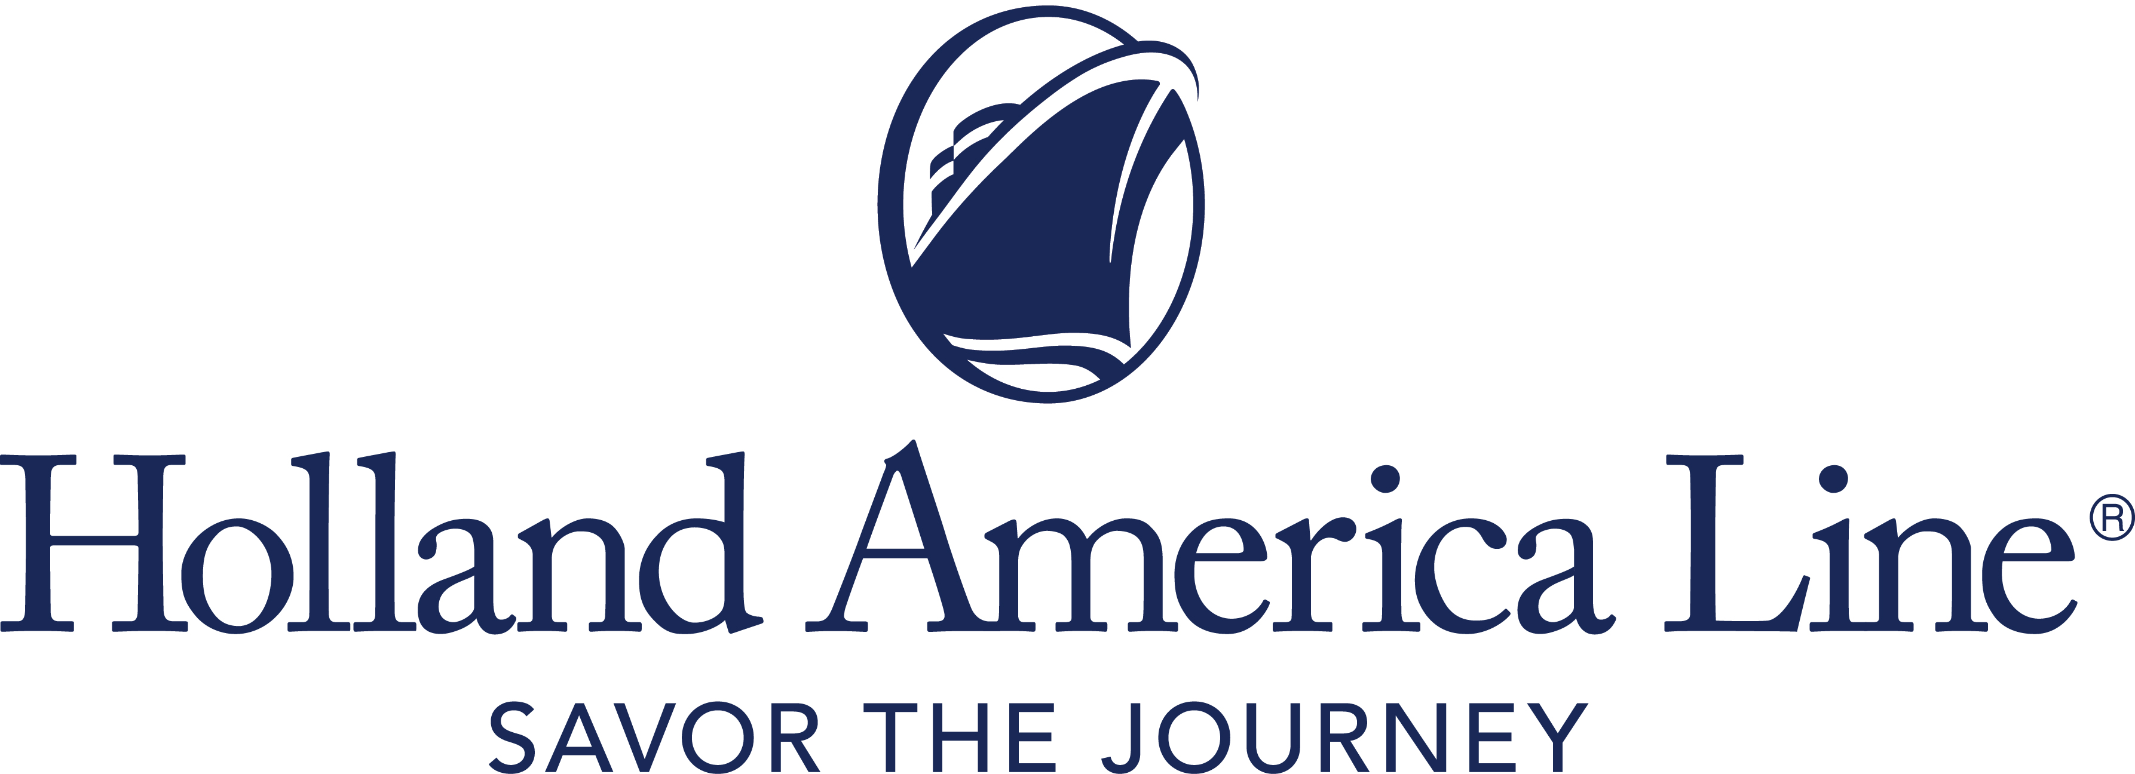
CONTACT: | Erik Elvejord
PHONE: | 800-637-5029, 206-626-9890
EMAIL: | pr@hollandamerica.com

Holland America Line to Restart Cruising from Greece in August 2021
Click to tweet: .@HALcruises to start cruising out of Greece with seven-day itineraries roundtrip from Piraeus (Athens) aboard Eurodam in August 2021. #ReadySetSail

Seattle, Wash., May 5, 2021 — Working in close coordination with the government of Greece, Holland America Line has received approval to restart cruising from Piraeus (Athens) in August with four departures aboard Eurodam. Bookings for these cruises will open May 6.

Departing Aug. 15 and 29, the “Idyllic Greek Isles” itinerary features Kotor, Montenegro, plus the Greek isles of Kékira (Corfu), Thíra (Santorini) and Mykonos. “Ancient Wonders” departs Aug. 22 to explore Haifa, Israel, as well as Náfplion, Mykonos and Rhodes in Greece. Both options can be combined to form a longer, back-to-back 14-day Collectors’ Voyage.

A seven-day “Adriatic Allure” itinerary departing Sept. 5 will sail from Piraeus to Venice, Italy, with calls at Mykonos, Katakolon (Olympia) and Crete (Chania), Greece, and Sarandë, Albania. Additional Mediterranean cruises aboard Eurodam through the fall will be announced in the coming weeks and include ports in Italy and Greece. Eurodam returns to the United States to begin sailing its published Caribbean cruises in mid-November.

“Everyone at Holland America Line has been preparing for our return to service, and we are grateful to the government of Greece for allowing us to show that we can safely operate our cruises,” said Gus Antorcha, president of Holland America Line. “The beautiful islands of Greece have been a highlight of our Mediterranean itineraries for decades, and we are honored to be able to restart out of Athens and give our guests a memorable vacation after all this time without cruise travel.”

“The Greek Islands have been welcoming Holland America Line ships for many years, and we are proud to work together to welcome the cruise line back this summer,” said Harry Theoharis, Minister of Tourism of Greece. “We are sure that all visitors to Greece will once again have unique experiences to our beautiful destinations and fully enjoy the rich history, culture and gastronomy of our nation.''

On board, Holland America Line will continue to offer the amenities that are a hallmark of the brand. Dining will be available in all restaurants and specialty venues, as well as room service. Entertainment will be in full swing in the main show lounge, and live music will be featured in Lincoln Center Stage, B.B. King’s Blues Club, Billboard Onboard and Rolling Stone Rock Room. Port-to-Table culinary demonstrations, EXC Talks and more will bring Greece and its culture on board through engaging activities. To accommodate physical distancing, additional performances may be added to the schedule.

Cruise and Stay Healthy with ‘Travel Well’ Protocols
Holland America Line cruises from Greece are available for guests who have received their final dose of an approved COVID-19 vaccine at least 14 days prior to the beginning of the cruise and have proof of vaccination.

Holland America Line guests will be required to comply with all health and safety protocols in place at the time of departure for travel to and from the ship, as well as all onboard protocols and procedures for visiting ports. Guests can find information about Greece traveler health requirements on the Visit Greece website.

Additional preventive health measures under Holland America Line’s “Travel Well” program will be in place, including health screenings, face mask requirements, physical distancing and capacity controls. The ships now feature enhanced environmental sanitation and air ﬁltration with upgraded HVAC systems and ultraviolet technology. HEPA ﬁlters will be used in key areas as a further safeguard. In addition, medical centers will be equipped with COVID-19 testing and treatment capabilities.

Holland America Line’s protocols are subject to change as work continues in collaboration with medical experts and government bodies to ensure the practices evolve in line with the latest advice.

Full details, including cruise fares and information on shore excursions, are being finalized and will be shared in the coming weeks at hollandamerica.com. Attractive airfares from several domestic and international gateways will be available through Holland America Line’s FlightEase program. Flexible cancellation terms, including our Covid-19 Protections, are offered through “Book with Confidence” when booked by June 30, 2021, for sailings through Dec. 31, 2021. The cruise line’s Cancellation Protection Plan also allows cancellation up to 24 hours in advance.

To accommodate the new Greece sailings, guests sailing on Eurodam’s published Seattle roundtrip Alaska cruises will be moved to similar accommodations on sister ship Nieuw Amsterdam, which is scheduled to sail on the same departure dates. In addition, European cruises departing from July 1 through July 25 on Volendam and July 1 through Aug. 31 on Westerdam will be cancelled. Guests who were booked on impacted cruises and their travel advisors are being notified.

Fares for Eurodam's seven-day Greece cruises begin at a “Have it All” premium package fare of $1,999 per person that includes one shore excursion, a beverage package, specialty dining and Wi-Fi. Cruise-only fares start at $1,649 per person, double occupancy. Taxes, fee and port expenses are additional.

For more information about Holland America Line, consult a travel advisor, call 1-877-SAIL HAL (877-724-5425) or visit hollandamerica.com.

Editor’s note: Photos are available at https://www.cruiseimagelibrary.com/c/lwmol0gs.

— # # # —

Find Holland America Line on Twitter, Facebook and the Holland America Blog. Access all social media outlets via the home page at hollandamerica.com.

About Holland America Line [a division of Carnival Corporation and plc (NYSE: CCL and CUK)]
Holland America Line has been exploring the world since 1873 and was the first cruise line to offer adventures to Alaska and the Yukon more than 70 years ago. Its fleet of premium ships visits more than 470 ports in 98 countries around the world, offering an ideal mid-sized ship experience. A third Pinnacle-class ship, Rotterdam, is under construction and will join the fleet in July 2021.

The leader in premium cruising, Holland America Line’s ships feature innovative initiatives and a diverse range of enriching experiences focused on destination exploration and personalized travel. The best live music at sea fills each evening at Music Walk, and dining venues feature exclusive selections from Holland America Line's esteemed Culinary Council, comprising world-famous chefs.
In light of COVID-19, Holland America Line is currently enhancing health and safety protocols and how they may impact future cruises. Our actual offerings may vary from what is displayed or described in marketing materials. Review our current Cruise Updates, Health & Safety Protocols and CDC Travel Advisories.
RTSGreesce21

