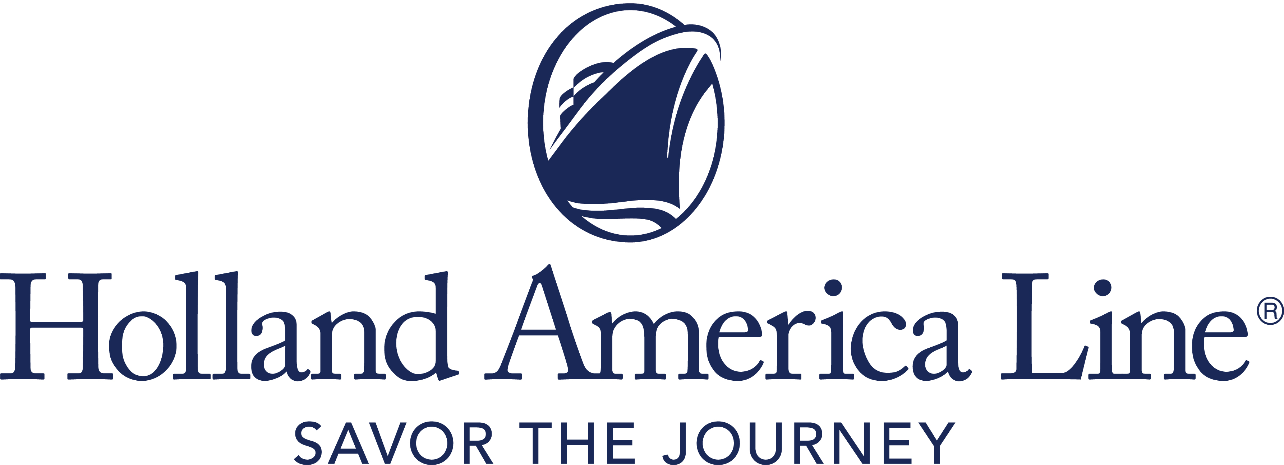
CONTACT: | Erik Elvejord
PHONE: | 800-637-5029, 206-626-9890
EMAIL: | pr@hollandamerica.com

Holland America Line Updates Summer 2021 Europe Cruise Schedule
Eurodam maintains recently announced Mediterranean season through October; Nieuw Statendam and Volendam cruises will be canceled; Rotterdam’s season shifted

Seattle, Wash., June 10, 2021 — While Holland America Line continues to work with governments and port authorities in correlation with the phased resumption of cruising, it is canceling the remainder of the summer 2021 European sailings aboard two ships, Nieuw Statendam and Volendam. This affects cruises that were scheduled to depart from September through November, along with the Collectors’ Voyages (combined cruises) associated with those departures.

In addition, after an expected on-schedule delivery from the Fincantieri shipyard July 30, Rotterdam will remain in non-guest operations until its Sept. 26 cruise from Amsterdam, the Netherlands. Plans for Rotterdam’s naming ceremony are being finalized.

Guests Moved to a Europe Cruise in 2021 or 2022
Guests currently booked on canceled Nieuw Statendam and Volendam departures automatically will be moved to a 2021 cruise on Eurodam in the Mediterranean, beginning with the Aug. 15 cruise through the Oct. 30 transatlantic crossing, and receive a $100 Onboard Spending Credit per person.

Nieuw Statendam and Volendam guests also can choose to move to an equivalent cruise in 2022 at the 2021 fare or receive a Future Cruise Credit of 110% of any cash paid that will be placed in the guest’s loyalty account.

Guests currently booked on a canceled Rotterdam voyage may select an equivalent sailing in 2022 at the 2021 fare paid, or they can choose to receive a Future Cruise Credit of 110% of any cash paid.

Any guest on a canceled voyage also can request a full refund of all monies paid to Holland America Line.

For more information about Holland America Line, consult a travel advisor, call 1-877-SAIL HAL (877-724-5425) or visit hollandamerica.com.

— # # # —

Find Holland America Line on Twitter, Facebook and the Holland America Blog. Access all social media outlets via the home page at hollandamerica.com.

About Holland America Line [a division of Carnival Corporation and plc (NYSE: CCL and CUK)]
Holland America Line has been exploring the world since 1873 and was the first cruise line to offer adventures to Alaska and the Yukon more than 70 years ago. Its fleet of premium ships visits nearly 400 ports in 114 countries around the world, offering an ideal mid-sized ship experience. A third Pinnacle-class ship, Rotterdam, is under construction and will join the fleet in July 2021.

The leader in premium cruising, Holland America Line’s ships feature innovative initiatives and a diverse range of enriching experiences focused on destination exploration and personalized travel. The best live music at sea fills each evening at Music Walk, and dining venues feature exclusive selections from Holland America Line's esteemed Culinary Council of world-famous chefs.

In light of COVID-19, Holland America Line is currently enhancing health and safety protocols and how they may impact future cruises. Our actual offerings may vary from what is displayed or described in marketing materials. Review our current Cruise Updates, Health & Safety Protocols and CDC Travel Advisories.

EuropeRTS21

