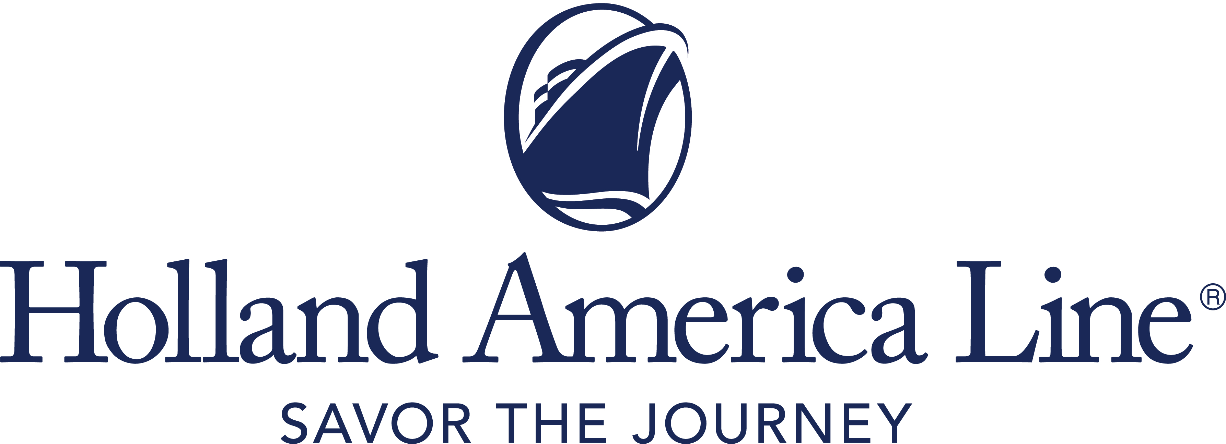
CONTACT: | Erik Elvejord
PHONE: | 800-637-5029, 206-626-9890
EMAIL: | pr@hollandamerica.com

Holland America Line Announces Fall Cruise 2021 Plans with Two Ships Operating West Coast Departures from San Diego and Four Ships Sailing in the Caribbean from Fort Lauderdale

Koningsdam to make West Coast debut with cruises to Mexico, Hawaii and California coast; Rotterdam sails maiden season in Caribbean

Seattle, Wash., June 21, 2021 — Holland America Line is gearing up to restart cruising out of Port of San Diego in California beginning with a season of cruises to Mexico, Hawaii and along the California coast aboard Koningsdam and Zuiderdam. The cruise line has expanded the season with the addition of six new cruise departures for Zuiderdam and two new cruises on Koningsdam, offering a total of 40 cruises from San Diego from September 2021 through April 2022.

With the resumption of service on the West Coast, Holland America Line also is looking toward cruising in the Caribbean with four ships. All sailing roundtrip from Fort Lauderdale, Florida, the season will begin Oct. 23, 2021, with Nieuw Amsterdam. The ship will be joined by the new Rotterdam Nov. 3, Eurodam Nov. 14 and Nieuw Statendam Nov. 21. Caribbean cruises range in length from four to 14 days, span the entire region and include a call at Half Moon Cay, Holland America Line’s award-winning private island.

“San Diego has always been an incredible homeport for our ships, and we are eager to restart on the West Coast with two ships operating an expanded season, including the debut of Koningsdam on these itineraries and close-to-home California cruises that our guests are going to love,” said Gus Antorcha, president of Holland America Line. “We’ve also been anticipating announcing our plans for the Caribbean and we’re thrilled to have four ships in the region, including our new Rotterdam. Cruising is back and having vaccinated ships for these cruises in 2021 ensures that we can deliver the experience just how our guests remember and expect. We’re ready to cruise!”

A Cruise Experience That is a Cruise
The on-board cruise experience will offer amenities that are a hallmark of the brand. Dining will be available in all restaurants and specialty venues, as well as room service. Entertainment will be in full swing in the main show lounge, and live music and dancing will be featured in Lincoln Center Stage, B.B. King’s Blues Club, Billboard Onboard and Rolling Stone Rock Room.

Port-to-Table culinary demonstrations, EXC Talks and other enrichment programming will bring regional cultures on board through engaging activities and special presentations. Guests may choose to explore port destinations independently or on ship-sponsored tours, following the local ports’ health guidelines.

Highlights of the 2021-2022 San Diego Cruise Season:
- Zuiderdam: Sept. 18, 2021, to April 22, 2022: 17 cruises from San Diego — eight Mexico, four California coast, three Hawaii and two Panama Canal.
- Koningsdam: Oct. 10, 2021, to April 3, 2022: 23 cruises from San Diego — 15 Mexico, six California coast and two Hawaii cruises.
- Seven-day cruises along the California coast include a new itinerary that calls at Catalina, Santa Barbara and San Francisco for a late evening stay, along with Ensenada, Mexico. Additional “Classic California Coast” cruises include California calls at Santa Barbara, San Francisco and Avalon, and at Ensenada.
- A new 21-day Panama Canal cruise on Nieuw Amsterdam from Seattle, Washington, to Fort Lauderdale departs Oct. 2 and includes calls at San Diego; Puerto Vallarta, Mexico; Fuerte Amador (Panama City), Panama;; Oranjestad, Aruba; and Half Moon Cay.
- All seven-day “Mexican Riviera” cruises feature three Mexican ports of call: Puerto Vallarta, Mazatlán and Cabo San Lucas.
- “Mexico and Sea of Cortez” itineraries are between nine and 12 days and call at a combination of Puerto Vallarta, Mazatlán, Cabo San Lucas, Guaymas, Topolobampo, Pichilingue (La Paz) and Loreto, Mexico.
- “Circle Hawaii” cruises are 17 or 18 days and call at the Hawaiian ports of Lahaina, Hilo, Honolulu, Nawiliwili and Kona, and Ensenada.
- Two 14-day cruises through the Panama Canal from San Diego to Fort Lauderdale on Zuiderdam depart Jan. 2 and Jan. 30, 2022.

Highlights of the 2021-2022 Caribbean Cruise Season:
- Nieuw Amsterdam: Oct. 23, 2021, to April 7, 2022: 24 cruises to the eastern, western and southern Caribbean. All itineraries are seven days except a nine-day holiday cruise departing Dec. 30.
- Rotterdam: Nov. 3, 2021, to April 10, 2022: The ship kicks off its maiden season in the Caribbean with a series of 22 cruises, ranging from three to 11 days covering a wide offering of Caribbean ports.
- Eurodam: Nov. 14, 2021, to April 10, 2022: 15 departures, including 12 10- and 11-day Panama Canal Sunfarer cruises featuring a partial Panama Canal exploration of Gatun Lake and three seven-day eastern Caribbean itineraries.
- Nieuw Statendam: Nov. 21, 2021, to March 27, 2022: 15 cruises to the eastern, western, southern and tropical Caribbean ranging from seven to 11 days.
- All itineraries include a call at Half Moon Cay, Holland America Line’s private Bahamian island. This quintessential sanctuary features the finest beaches in the Caribbean; a natural 700-acre lagoon; incredible two-story villas and private cabanas; delicious dining venues like Lobster Shack; and a variety of fun-filled shore excursions for nature lovers, adventurous travelers and explorers.
Awards and Accolades for Top Destination Cruise Experiences
Holland America Line took home the Editor's Pick Award for the best Hawaii sailings in the 2020 TravelAge West Wave Awards. In 2019, the company was named “Best in the Mexican Riviera” in the Cruise Critic Cruisers’ Choice Awards, solidifying the line as the number-one choice in the region. Both Porthole Cruise Magazine and Travel Weekly readers have named Half Moon Cay the industry’s Best Private Island.

Cruise and Stay Healthy
These Holland America Line cruises in 2021 are available for guests who have received their final dose of an approved COVID-19 vaccine at least 14 days prior to the beginning of the cruise and have proof of vaccination. Holland America Line will continue to monitor the latest guidance from the Centers for Disease Control and Prevention, as well as local, state and federal officials in the homeports and ports of call. Onboard protocols and vaccination requirements will be adjusted as necessary. Shipboard crew vaccinations will also be in accordance with CDC guidelines.

2021 Cruises to Asia, Australia and South America Canceled
While Holland America Line continues to work with governments and port authorities in coordination with the phased resumption of cruising in other areas of the world, the company is canceling cruises in Asia, Australia and New Zealand and South America through the remainder of 2021, along with the Collectors’ Voyages (combined cruises) associated with those departures. This affects itineraries on Noordam (Asia), Oosterdam (Australia) and Westerdam (South America). In addition, fall sailings through the end of 2021 on Volendam and Zaandam also are cancelled.

Options for Guests on Canceled Cruises
Guests currently booked on canceled departures will be moved automatically to a comparable 2021 voyage or an equivalent 2022 departure at the current per-day fare paid and in the same or equivalent stateroom category. They may also opt to receive a Future Cruise Credit of 110% of any cash paid that will be placed in the guest’s loyalty account. Any guest on a canceled voyage also can request a full refund of all monies paid to Holland America Line.

For more information about Holland America Line, consult a travel advisor, call 1-877-SAIL HAL (877-724-5425) or visit hollandamerica.com.

Editor’s note: Photos/video are available at https://www.cruiseimagelibrary.com/c/vl2lfm3k.

— # # # —

Find Holland America Line on Twitter, Facebook and the Holland America Blog. Access all social media outlets via the home page at hollandamerica.com.

About Holland America Line [a division of Carnival Corporation and plc (NYSE: CCL and CUK)]
Holland America Line has been exploring the world since 1873 and was the first cruise line to offer adventures to Alaska and the Yukon more than 70 years ago. Its fleet of premium ships visits nearly 400 ports in 114 countries around the world, offering an ideal mid-sized ship experience. A third Pinnacle-class ship, Rotterdam, is under construction and will join the fleet in July 2021.

The leader in premium cruising, Holland America Line’s ships feature innovative initiatives and a diverse range of enriching experiences focused on destination exploration and personalized travel. The best live music at sea fills each evening at Music Walk, and dining venues feature exclusive selections from Holland America Line's esteemed Culinary Council of world-famous chefs.

In light of COVID-19, Holland America Line is currently enhancing health and safety protocols and how they may impact future cruises. Our actual offerings may vary from what is displayed or described in marketing materials. Review our current Cruise Updates, Health & Safety Protocols and CDC Travel Advisories.

RTSFallCruises21

