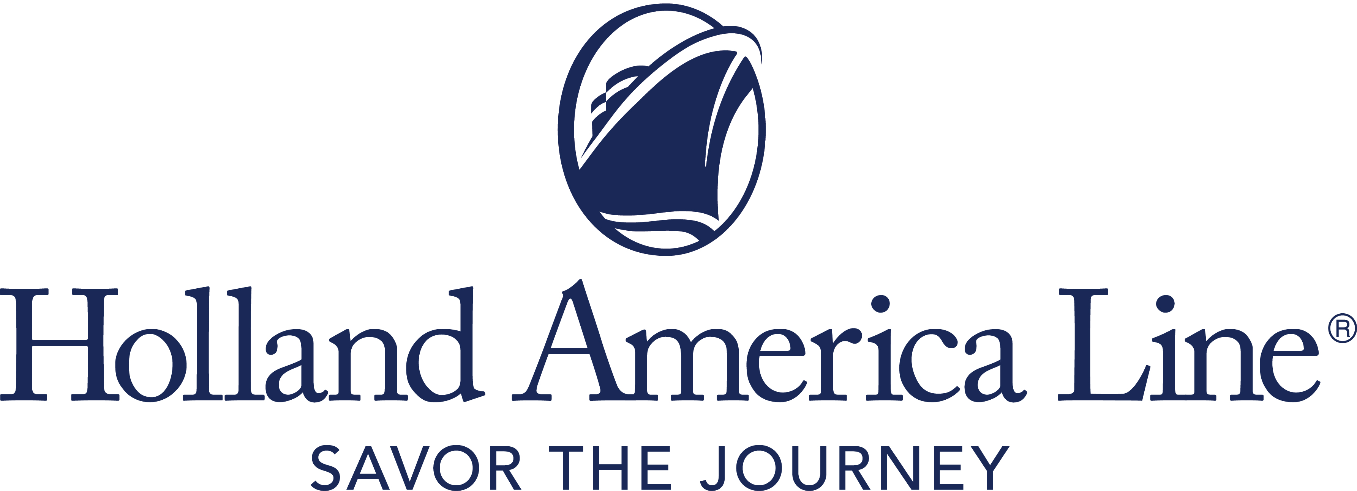
CONTACT: | Erik Elvejord
PHONE: | 800-637-5029, 206-626-9890
EMAIL: | pr@hollandamerica.com

Holland America Line Announces Spring 2022 Return-to-Service Dates for Final Three Ships in the Fleet
Noordam, Oosterdam and Westerdam to resume cruising with plans for Japan, the Mediterranean and Alaska, respectively

Seattle, Wash., Sept. 8, 2021 — By late spring 2022, Holland America Line will have a complete fleet back to cruising with the restart of operations for Noordam, Oosterdam and Westerdam. Noordam will restart with a March 14, 2022, cruise in Japan; Oosterdam will begin cruising May 1 in the Mediterranean, and Westerdam will return to service May 8 in Alaska.
The ships will join Eurodam, Koningsdam, Nieuw Amsterdam, Nieuw Statendam, Rotterdam and Zuiderdam, which have returned to service or are slated to restart cruising by December 2021. Volendam and Zaandam will return in May 2022.
“We’ve been working intensely to get all of our ships back into service, and to have final restart dates that will complete the fleet is rewarding for everyone who has put their all into making this happen,” said Gus Antorcha, president of Holland America Line. “Our progressive rollout plan allows us to be back in full service over the next several months, and we look forward to welcoming guests on all 11 ships cruising in different regions around the world.”

Noordam Plans Return to Service in Japan
Holland America Line is working with Japanese authorities to begin cruising for Noordam next spring in Japan with four sailings scheduled.

When Noordam sets sail in March, the ship plans to offer three 14-day cruises that deeply explore Japan. Sailing roundtrip from Yokohama (Tokyo), Japan, the ship makes several calls around the exotic country and with a one- or two-day visit on each itinerary to South Korea, Taiwan or Russia. The 14-day journeys can be combined to form 28-day Collectors’ Voyages.

In April, Noordam will cross the Pacific Ocean and sail a season in Alaska with cruises between Vancouver, British Columbia, Canada, and Whittier, Alaska.

Oosterdam Returns to the Mediterranean
Guests eager to visit the Med next year can embark Oosterdam beginning with the May 1 departure. The ship will sail the season in the region, cruising between Civitavecchia (Rome) and Venice, Italy; and Barcelona, Spain, and Venice; or roundtrip from Venice on seven- and 12-day itineraries. Oosterdam will explore ports in Italy, Greece, Turkey, Montenegro, Croatia, Albania, France, Malta and Israel.

Following a transatlantic crossing in November 2022, the ship will transit the Panama Canal and take a southerly route to offer a series of South America and Antarctica expeditions ranging from 14 to 22 days between Buenos Aires, Argentina, and San Antonio (Santiago), Chile.

Westerdam Sets Sail for Alaska
When Westerdam returns on May 8, the ship will embark on a season of seven-day Alaska cruises roundtrip from Seattle, Washington. Come September, the ship will cross the Pacific Ocean and begin a season in the Far East offering a variety of 14-day itineraries from Singapore; Hong Kong, China; and Yokohama (Tokyo).

Guests on January to May 2022 Cruises Will Move to 2023
With these restart dates for Noordam, Oosterdam and Westerdam, cruises in Asia, Australia and New Zealand, and South America and Antarctica from January 2022 through the return-to-service departures will be cancelled.

Guests on Westerdam’s cancelled transatlantic crossing departing April 18, 2022, will be moved to a comparable crossing on Nieuw Statendam departing April 17.

Guests on Noordam’s affected Asia departures in 2022 will be moved to the same itinerary in 2023 aboard Westerdam; guests on Oosterdam’s cancelled Australia and New Zealand voyages will be moved to the same itinerary in 2023 aboard Noordam; and guests on Westerdam’s cancelled South America and Antarctica Voyages will be moved to the same itinerary aboard Oosterdam in 2023. Guests also may choose to receive a 100% refund of monies paid to Holland America Line.

The above options are not applicable to guests booked on a charter sailing. Other booking and cancellation conditions and policies may apply if the cruise was not booked through Holland America Line.

For more information about Holland America Line, consult a travel advisor, call 1-877-SAIL HAL (877-724-5425) or visit hollandamerica.com.

— # # # —

Find Holland America Line on Twitter, Facebook and the Holland America Blog. Access all social media outlets via the home page at hollandamerica.com.

About Holland America Line [a division of Carnival Corporation and plc (NYSE: CCL and CUK)]
Holland America Line has been exploring the world since 1873 and was the first cruise line to offer adventures to Alaska and the Yukon nearly 75 years ago. Its fleet of premium ships visits nearly 400 ports in 114 countries around the world, offering an ideal mid-sized ship experience. A third Pinnacle-class ship, Rotterdam, joined the fleet in July 2021.

The leader in premium cruising, Holland America Line’s ships feature innovative initiatives and a diverse range of enriching experiences focused on destination exploration and personalized travel. The best live music at sea fills each evening at Music Walk, and dining venues feature exclusive selections from Holland America Line's esteemed Culinary Council of world-famous chefs.

In light of COVID-19, Holland America Line is currently enhancing health and safety protocols and how they may impact future cruises. Our actual offerings may vary from what is displayed or described in marketing materials. Review our current Cruise Updates, Health & Safety Protocols and CDC Travel Advisories.

FullFleetRTS21

